COMMERCIAL METEOROLGY SAMPLE EXAM

You planned a flight in a Cessna 172 from Halifax/Stanfield International Airport (CYHZ) to St. John’s International Airport (CYYT), with an intermediate stop at Charlottetown (CYYG). The following information is given:

- all relevant weather and other information required to answer all questions, contained in either figures or text

- assumed departure time is 1900Z from CYHZ

- assumed arrival time into CYYG is 1600 local, with a departure from

CYYG ten minutes later

- assumed arrival into CYYT is estimated at 2330Z

- times are assumed as this flight would not be undertaken in reality (you should be able to point out multiple reasons why!), but for the purposes of this exercise assume you are flying the entire route at the given times and altitude

- CYYG local standard time is UTC/ZULU -4

- CYHZ elevation: 477’ ASL

- CYYG elevation: 160’ ASL

- CYYT elevation: 461’ ASL

- CYHZ magnetic variation is 19˚W

- all legs of the flight are to be conducted at an indicated cruising altitude of 2000’

***THESE QUESTIONS ARE DESIGNED TO BE SPECIFIC TO TRANSPORT CANADA’S STYLE SO BE THOROUGH AND READ CAREFULLY.***

***GOOD LUCK!***

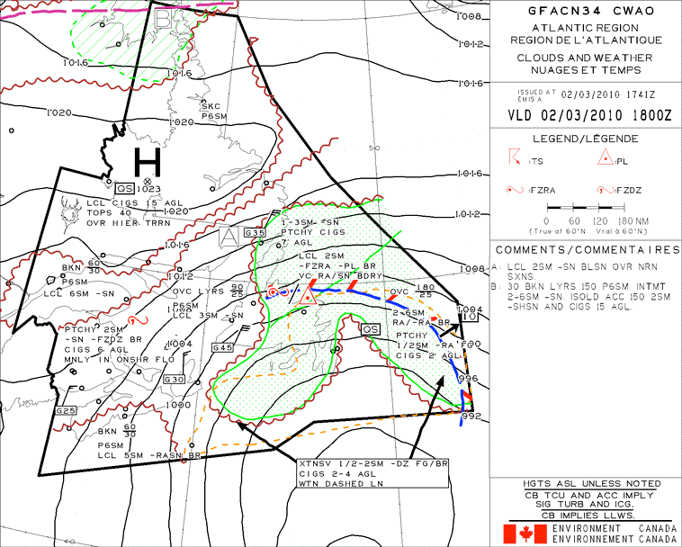

FIGURE 1

Halifax Charlottetown St. John’s

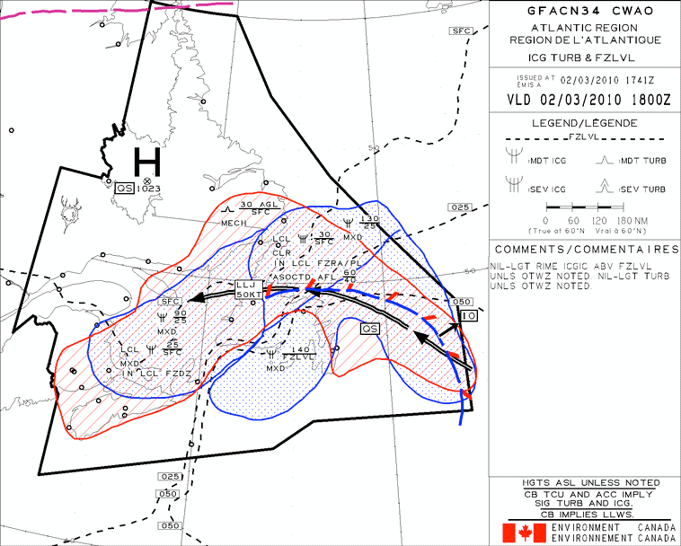

Halifax Charlottetown St. John’s

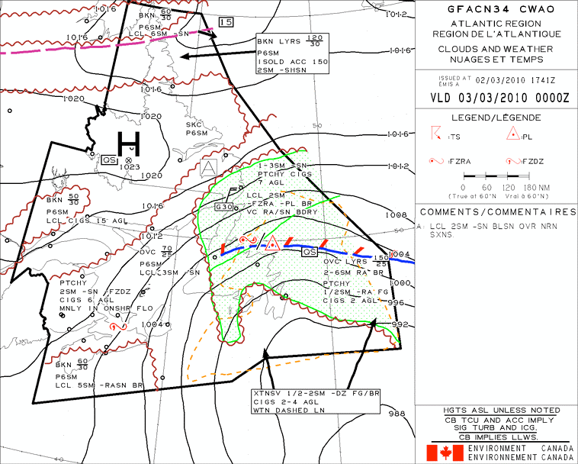

Halifax Charlottetown St. John’s

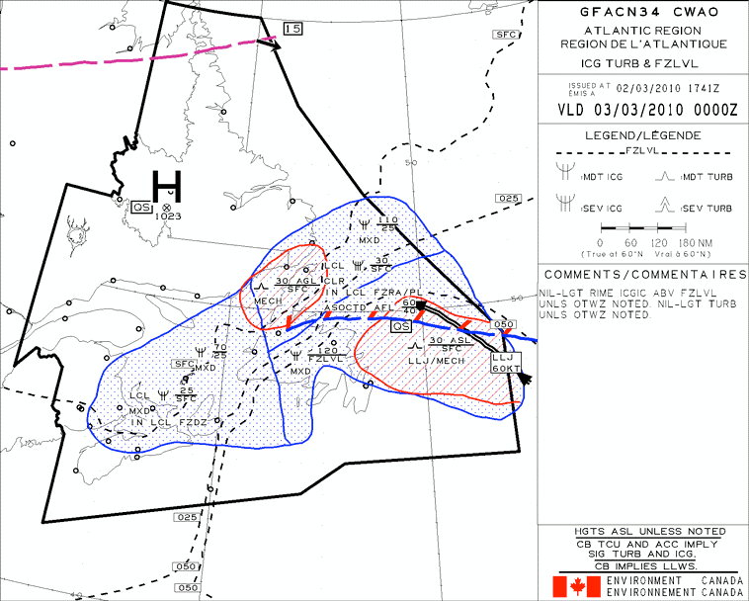

Halifax Charlottetown St. John’s

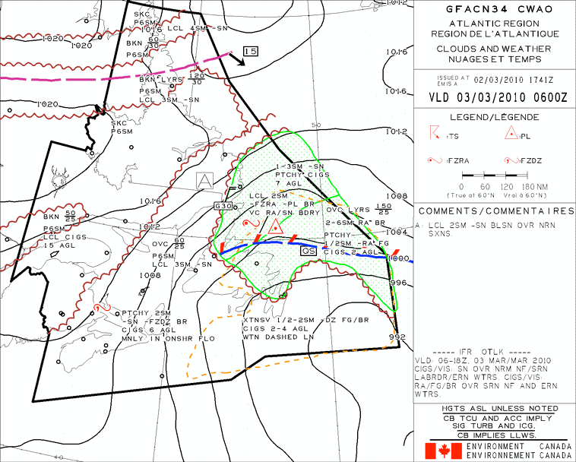

Halifax Charlottetown St. John’s

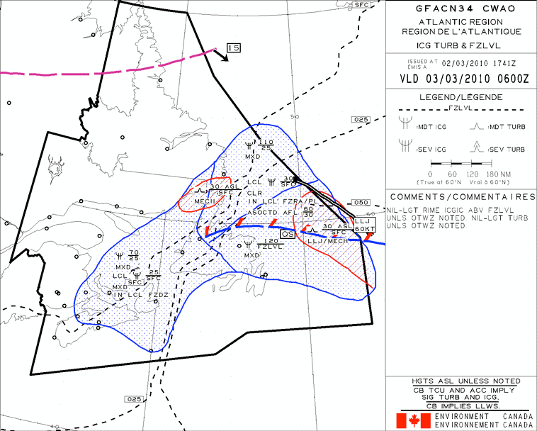

FIGURE 6

Halifax Charlottetown St. John’s

TEXT 1

**METAR CYHZ 022100Z 35017G24KT 15SM -SHSN OVC012 M01/M03 A2972 RMK SC8**

**SLP070=**

**METAR CYHZ 022000Z 35021KT 10SM -SHSN OVC011 M01/M02 A2970 RMK SC8**

**SLP063=**

**SPECI CYHZ 021936Z 36019G24KT 10SM -SHSN SCT006 OVC011 M01/ RMK SF3SC5=**

**SPECI CYHZ 021931Z 36019G25KT 2SM -SHSN OVC006 M00/ RMK SN1SF7=**

**METAR CYHZ 021900Z 35019G25KT 12SM -SHSN OVC010 M00/M03 A2968 RMK SC8**

**SLP056=**

**METAR CYYG 022100Z 36016G21KT 1SM R03/P6000FT/N -SN BR BKN007 OVC020**

**M02/M02 A2979 RMK SF6SC2 SLP089=**

**METAR CYYG 022000Z 36013G24KT 1 1/2SM -SN BR OVC007 M02/M02 A2977 RMK SF8 SLP083=**

**METAR CYYG 021900Z 36012G24KT 1 1/2SM -SN BR OVC008 M01/M01 A2976 RMK SF8 SLP080=**

**METAR CYYT 022100Z 08007KT 3/8SM R11/1600FT/N R16/2200FT/N -RADZ FG VV002 02/01 A2939 RMK FG8 SLP957=**

**SPECI CYYT 022046Z 07008KT 3/8SM R11/2000FT/N R16/2800FT/N -DZ FG VV002 02/ RMK FG8=**

**SPECI CYYT 022018Z 09011KT 3/8SM R11/2000FT/N R16/2800FT/N -RADZ FG VV002 02/ RMK FG8=**

**METAR CYYT 022000Z 08012KT 3/8SM R11/2200FT/N R16/2800FT/N -DZ FG VV002 02/01 A2936 RMK FG8 SLP950=**

**METAR CYYT 021900Z 06009KT 1/4SM R11/1200FT/N R16/1200FT/N -DZ FG VV002 02/02 A2937 RMK FG8 SLP952=**

**TAF CYHZ 022043Z 0221/0318 35018G28KT 4SM -SHSN BR FEW006 OVC010**

**TEMPO 0221/0224 P6SM NSW OVC015**

**FM030000 35015G25KT 6SM -SHSN OVC015 TEMPO 0300/0315 21/2SM -SHSN OVC008**

**BECMG 0302/0304 36012G22KT**

**FM031500 01015KT P6SM -SHSNRA OVC020**

**RMK NXT FCST BY 030000Z=**

**TAF CYYG 021742Z 0218/0306 36018G30KT 1SM -SN BR OVC005 TEMPO**

**0218/0302 6SM -SN -FZDZ BR SCT005 OVC010**

**FM030200 36015G25KT 21/2SM -FZDZ BR OVC005 TEMPO 0302/0306 6SM**

**-SN BR SCT005 OVC012**

**BECMG 0303/0305 35012G22KT RMK NXT FCST BY 030000Z=**

**TAF CYYT 021738Z 0218/0318 06012KT 1/8SM -DZ FG VV001**

**BECMG 0302/0304 09010KT BECMG 0307/0309 05005KT**

**FM031200 35005KT 1/4SM -DZ FG VV002 TEMPO 0312/0314 1SM -DZ BR OVC004**

**FM031400 35005KT 3/4SM -DZ BR VV003 TEMPO 0314/0318 3SM -DZ BR OVC006**

**RMK NXT FCST BY 030000Z=**

|  |  |  |  |  |  |  |
| --- | --- | --- | --- | --- | --- | --- |
| **STN YHZ - HALIFAX. NS** | **for use** | **3000** | **6000** | **9000** | **12000** | **18000** |
| FDCN01 CWAO FCST BASED ON 021200 DATA **VALID**  **021800** | **17-21** | 3634 | 0217-01 | 3510-06 | 3611-12 | 3616-25 |
| FDCN02 CWAO FCST BASED ON 021200 DATA **VALID**  **030000** | **21-06** | 0135 | 0115-02 | 3310-05 | 3008-11 | 2917-24 |
| FDCN03 CWAO FCST BASED ON 021200 DATA **VALID**  **031200** | **06-17** | 0327 | 0405-04 | 3411-07 | 2609-12 | 2631-23 |

|  |  |  |  |  |  |  |
| --- | --- | --- | --- | --- | --- | --- |
| **STN YYT - ST. JOHN'S. NFLD** | **for use** | **3000** | **6000** | **9000** | **12000** | **18000** |
| FDCN01 CWAO FCST BASED ON 021200 DATA **VALID**  **021800** | **17-21** | 1142 | 1032+01 | 1026-04 | 1017-10 | 1315-23 |
| FDCN02 CWAO FCST BASED ON 021800 DATA **VALID**  **030000** | **21-06** | 3614 | 1016+02 | 1211-02 | 1121-08 | 1122-23 |
| FDCN03 CWAO FCST BASED ON 021200 DATA **VALID**  **031200** | **06-17** | 0415 | 9900+00 | 9900-04 | 0806-09 | 1607-22 |

100144 CYHZ HALIFAX/STANFIELD INTL

CYHZ TWY A CLSD FM TWY C TO RWY 05/23 DLY 1200/2200

1003021200 TIL 1003032200

CYYG RSC 03/21 100 FT CL 20 PERCENT BARE AND DAMP 20 PERCENT DRY SN TRACE 60 PERCENT ICE REMAINDER 100 PERCENT DRY SN 1/2INS

1003022309

CYYG CRFI 03/21 -2 .31 1003022309

CYYG RSC 10/28 100 FT CL 80 PERCENT BARE AND WET 20 PERCENT WET SN

1/2IN REMAINDER 50 PERCENT BARE AND WET 50 PERCENT WET SN 1/2IN

1003022012

QUESTIONS

1) Which of the following are correct validity times for GFAs?

A. 04Z, 10Z, 16Z, 22Z

B. 12am, 6am, 12pm, 6pm

C. 0000 local, 0600 local, 1200 local, 1800 local

D. 00Z, 06Z, 12Z, 18Z

2) A GFA forecasts weather conditions from the surface up to

A. 10000’ ASL B. 24000’ ASL C. 24000’ AGL D. 18000’ ASL

3) On departure from CYHZ, taking into account all available information, the aircraft would perform as if it was at what altitude?

A. - 683’ ASL B. 240’ ASL C. 237’AGL D. - 717’ASL

4) Which set of GFA charts should be used to give a visual forecast of conditions expected on departure from CYHZ?

A. the 2nd B. the 3rd C. the 1st

D. the clouds and weather chart

5) Departing CYHZ the cloud base and top, respectively, is forecast to be

A. 600’ AGL, 1004’ ASL and constitute a VFR ceiling

B. 3000’ AGL, 6000’ ASL and broken

C. 3000’ ASL, 6000’ ASL and overcast

D. 3000’ ASL, 6000’ ASL and broken

6) On takeoff from CYHZ which runway would most likely be in use?

A. 05

B. 23

C. 32

D. 14

7) Would the desired cruise altitude be able to be reached while flying VFR on departure from CYHZ?

A. No

B. Yes

C. Not within a minimum of a 5 NM radius of CYHZ D. Not within a minimum of a 10 NM radius of CYHZ

8) When climbing out of CYHZ, light turbulence is experienced. This turbulence

A. was not forecast

B. is more intense than the moderate mechanical turbulence forecast

C. is not forecast to continue throughout the flight

D. was forecast

9) The prevailing visibility on departure while taking off from CYHZ is

A. 1.2 SM

B. worse than forecast

C. varying visibility

D. better than forecast

10) Wind barbs will be included in a GFA if the wind speed is forecast to

A. be 20 knots or higher

B. exceed 25 knots

C. gust

D. exceed 10 knots

11) En route from CYHZ to CYYG, the current METAR from CYYG may obtained by

A. calling on 126.70 KHz

B. calling on 126.70 MHz

C. calling on local FISE frequency

D. calling on 121.50 MHz

12) The forecast icing conditions on arrival into CYYG are

A. expected from 2500’ ASL to 9000’ ASL B. because of clear ice

C. expected in less than 25% of the bordered area from the surface to

2500’ ASL due to freezing drizzle

D. due to large super-cooled water droplets

13) The lowest ceiling forecast for CYYG at the assumed time of arrival is:

A. 1000’ ASL B. 1000’ AGL C. 500’ AGL D. 500’ ASL

14) The winds on arrival in CYYG are forecast to be gusting because

A. the gust factor is 30 knots

B. the winds are from the north

C. there is horizontal wind shear forecast

D. the wind speed is expected to exceed the forecast average mean wind speed by more than 5 knots and the gust speed is forecast to be 15 knots or higher

15) In reality, a takeoff from CYHZ should not be attempted due to

A. the icing conditions forecast to be encountered en route

B. the planned cruise altitude may not be able to be maintained due to cloud

C. the visibility at assumed time of arrival in CYYG is reported as 1 SM

D. all of the above

16) On approach to CYYG you encounter a 40 knot headwind, which just before touchdown reduces to a 10 knot headwind. The required net power change to maintain the ideal approach after passing through the shear zone, compared to the power required to maintain an ideal approach before encountering the shear, would be

A. classified as increased performance shear

B. a net decrease in power

C. a net increase in power

D. negligible

17) The mist observed on take-off from CYYG at the assumed departure time is most likely due to

A. a temperature - dew point spread of zero

B. a low cloud ceiling

C. the proximity of the airport to the coast

D. the poor visibility

18) You have decided to delay take-off from CYYG with the hopes that the conditions will improve. You could expect in the foreseeable future

A. the wind to veer

B. the occurrence of heavy freezing drizzle

C. the visibility to marginally improve

D. the next TAF to be issued at 0000Z on the 2nd day of the month

19) Information on runway condition will be published in

A. the remarks section of a METAR

B. the aerodrome NOTAM file in a runway surface condition report

C. the comments box of a GFA

D. in the Canada Flight Supplement

20) Taking off from CYYG the wind is seen to veer and increase in speed. This is due to

A. horizontal wind shear

B. reduced surface friction

C. a decrease in coriolis force

D. centripetal force

21) Atmospheric density decreases with a(n)

A. increase in temperature, increase in relative humidity and an increase in altitude

B. decrease in temperature, decrease in relative humidity and a decrease in altitude

C. decrease in temperature, decrease in relative humidity and an increase in altitude

D. increase in temperature, increase in relative humidity and a decrease in altitude

22) As you fly eastbound en route to CYYT, a(n) in mean sea level pressure will be encountered.

A. decrease

B. increase

C. negligible change

D. decrease of 8 mb

23) The area bordered by a dashed orange line encompassing CYYT is indicative of

A. continuous precipitation

B. a trowal

C. obscuring phenomena

D. organized clouds

24) The dominating area of high pressure north of your route of flight

A. is also referred to as a cyclone

B. has a highest mean sea level pressure reading of 102.3 mb

C. is moving significantly throughout the GFA forecast period

D. has winds rotating clockwise and away from its center

25) The fog which is forecast surrounding CYYT is most likely due to

A. advection

B. radiation

C. orographic lift

D. sublimation

26) In the vicinity of the trowal lying over Newfoundland, and

are forecast.

A. freezing drizzle and snow grains

B. freezing rain and ice pellets

C. calm winds and good visibility

D. thunderstorms and freezing drizzle

27) When flying from the cold air sector towards a winter warm front, you would expect to encounter, in order,

A. rain, freezing rain, ice pellets, snow grains and snow

B. rain, snow and freezing rain

C. snow, ice pellets, freezing rain and rain

D. a temperature drop followed by a further drop as you fly through the frontal surface

28) The letters QS in the box associated with the trowal indicate

A. a quickly stopped front

B. that the trowal is moving at a speed of less than 5 knots

C. that conditions should improve rapidly

D. that there is a strong pressure gradient force driving the trowal

29) Associated with the trowal near CYYT is a forecast of freezing rain, which in turn is responsible for a forecast of

A. severe rime ice

B. clear ice covering more than fifty percent of the bounded area

C. mixed icing above 12000’ ASL

D. severe localized clear icing from 4000’ to 6000’ above the freezing level

30) Isotherms are drawn apart on an icing and turbulence GFA.

A. 4 mb B. 2000’ C. 2500’ D. 1000’

31) With regards to the low level jet running parallel to the trowal over

Newfoundland,

A. its length is forecast to shorten but its intensity is forecast to increase as you approach CYYT

B. it is indicating a direction opposite to that expected

C. it will produce calm winds which may be taken advantage of on a westbound flight

D. it is forecast to move south of the trowal by 0600Z on the 3rd

32) The most probable reason for the issuance of a SPECI for CYYT at 2018Z is

A. because the wind speed decreased

B. the RVR on runway 11 decreased

C. because of the occurrence of light rain

D. because of the lower than standard altimeter setting

33) The reported ceiling at CYYT at 2100Z is

A. due to fractus clouds at 200’ AGL B. the VV reading

C. because there is no change in the RVR readings

D. because there is a large spread between temperature and dew point

34) Mean sea level pressure differs from station pressure in that

A. station pressure is reduced to a common standard

B. station pressure is expressed in metric units whereas mean sea level pressure is expressed in imperial units

C. sea level pressure can not be used for comparative purposes

D. sea level pressure is station pressure reduced to a common standard

35) The upper level wind at your desired cruising altitude as you approach CYYT

is forecast to be closest to

A. 110 degrees true at 42 knots

B. 110 degrees magnetic at 42 knots

C. 360 degrees true at 14 knots

D. 360 degrees magnetic at 14 knots

36) Temperatures are not given for the 3000’ ASL level in FDs because

A. of temperature variation in the lower levels of the troposphere

B. of inadequate forecasting equipment

C. of convective cooling

D. the standard lapse rate allows this calculation to be made

37) The greatest hazard associated with the freezing rain and ice pellet forecast is

A. a decrease in airfoil lift

B. the requirement for a thrust increase leading to higher fuel burn

C. an increase in aircraft stalling speed

D. an increase in aircraft gross weight

38) With regards to the icing forecast at CYYT on the 0000Z GFA, A. no icing conditions are forecast at this time

B. there is moderate mixed icing forecast at 5000’ ASL C. light icing will exist at 16000’ ASL

D. the rate of catch will be greater in a Cessna when compared to a large passenger jet travelling at the same speed

39) According to the CYYT FD, at 2100Z there will be a strong headwind if flying eastbound, meaning the center of low pressure will be to the of track.

A. left

B. north

C. center

D. right

40) Noting the isobaric patterns and position of the low as you approach CYYT, a heading correction to the could be expected in order to maintain your track en route from CYYG.

A. left

B. south C. east D. right

41) You are approaching CYYT en route from CYYG. You set your altimeter to

29.77 on departure from CYYG. If you forget to reset your altimeter, upon landing at CYYT at an early arrival time of 2100Z your altimeter will read

A. 380’ low

B. 461’ ASL

C. the elevation of CYYG D. 380’ high

42) The presence of the trowal and the forecast for a large area of obscuring phenomena surrounding CYYT would indicate

A. a steep positive lapse rate

B. an inversion

C. very unstable air, especially in the lower levels

D. an absence of condensation nuclei

43) Radiation fog will not likely form

A. when there is a low overcast cloud layer present

B. with light surface winds

C. during the night

D. in low lying areas such as valleys

44) A METAR issued by a station that is at 2000’ ASL reports a cloud height as

070. This cloud would be classified

A. a low cloud

B. a cloud of vertical development

C. a middle cloud

D. either B. or C.

45) A NOTAM with the term APRX indicates

A. this NOTAM is issued at an approximate time

B. the station issuing the NOTAM is greater than 5 NM away from the location described within the NOTAM

C. a cancelling or amending NOTAM must be issued

D. this NOTAM is valid for an approximate duration of time

46) Choose the statement that is FALSE. After cold frontal passage

A. winds will veer

B. the pressure will decrease

C. the temperature will decrease

D. skies will usually clear

47) Out of the following, choose the correct statements which apply to thunderstorms:

1. thunderstorm formation is dependent on the stability of the air

2. there are 4 main stages of a thunderstorm

3. latent heat of vaporization cools the surrounding air

4. thunderstorms are characterized by air which has a steep lapse rate

5. downdrafts are most prevalent during the mature stage

6. the gust front may cause altimeters to over read

A. 2, 4, 5

B. 1, 2, 5, 6

C. 1, 4, 6

D. 2, 5, 6

48) Steam fog is formed due to

A. a reduction in air temperature

B. an increase in dew point temperature

C. air becoming saturated due to adiabatic expansion

D. the evaporation of moisture from warm bodies of water into cold air

49) Standard atmosphere implies

A. a mean sea level pressure of 1013.2 KPa

B. a lapse rate of 2.5 degrees Celsius per 1000’ of altitude gain

C. relative humidity is zero

D. a mean sea level temperature world-wide of 15 degrees F

50) The TEMPO in the TAF coinciding with your assumed arrival time in CYYG

indicates that light freezing drizzle will

A. occur for no more than a total of 3 hours B. occur for no more than a total of 4 hours C. occur for more than 1 hour consecutively

D. continue to be forecast as a permanent change in the TAF from 0200Z

on the 3rd

51) A warm front has a slope of 1:300. An aircraft flying at 6000 feet would encounter the frontal surface nautical miles past the surface position of the front.

|  |  |
| --- | --- |
| A. | 100 |
| B. | 150 |
| C. | 200 |
| D. | 300 |

52) With the passage of a warm front the winds will . With the passage of a cold front the winds will .

A. back, veer B. veer, veer C. back, back D. veer, back

53) A cold front advances towards a warm front because

A. the pressure gradient force is affecting the cold frontal movement

B. the cold air is denser than the warm air

C. the cold air has more momentum than the warm air

D. all of the above

54) A mass of air is overrun during a warm front occlusion.

A. cool B. warm C. cold D. dry

55) Wind shear encountered on approach will necessitate a

A. net decrease in power if increased performance shear is encountered B. net increase in power if decreased performance shear is encountered C. pitch nose up if decreased performance shear is encountered

D. net decrease in power if decreased performance shear is encountered

56) cA follows a south-westerly track and modifies to mA. This will create

A. stability in its lower levels

B. instability in its upper levels

C. an inversion

D. a steep lapse rate in its lower levels

57) The intensity of turbulence corresponding to momentary losses of aircraft control is termed

A. extreme

B. moderate

C. moderate chop

D. severe

58) The apparent effects of Coriolis are most evident

A. on north and south tracks B. on east and west tracks C. at the poles

D. in the surface based layers

59) When comparing surface winds over an ocean versus those over a land

mass, the winds over the ocean can be expected to cross isobars at an angle of

A. 20 degrees B. 30 degrees C. 25 degrees D. 40 degrees

60) The 250 hPa upper-air analysis chart corresponds to an approximate height of

A. 10000 feet B. 18000 feet C. 24000 feet D. 34000 feet

61) Upper-air analysis charts

A. forecast significant weather for surface based levels

B. analyze standard pressure levels in decametres above sea level

C. do not forecast upper winds

D. depict only the lowest altitude a particular standard pressure level is found at for a given zulu time

62) An IFR outlook is contained on the .

A. icing and turbulence chart of the 2nd GFA set B. clouds and weather chart of the 1st GFA set C. icing and turbulence chart of the 3rd GFA set D. clouds and weather chart of the 3rd GFA set

63) Altitude corrected for instrument error but not for non-standard temperature or pressure is

A. CALT B. TALT C. AALT D. IALT

64) The station with the highest DALT is

A. at a high elevation with high relative humidity

B. at a high elevation with low relative humidity

C. at a high elevation in July in the southern hemisphere

D. at a high elevation with low temperature

65) A process involved in atmospheric heating but not atmospheric cooling is

A. radiation B. advection C. expansion D. convection

66) Altimeters will over-read in below ISA temperature conditions because

A. the aneroid capsule within the sensitive altimeter is prevented from normal expansion and contraction

B. molecules in the cold air have higher kinetic energy than those in warm air

C. the vertical pressure gradient is shallow in cold air

D. the vertical pressure gradient is steep in cold air

67) Ground visibility is reported in statute miles because

A. nautical miles are able to be measured by instrumentation only

B. it is of increased benefit to pilots on approach

C. line of sight does not follow the curvature of the earth

D. statute miles are more commonly used in aviation than nautical miles

68) RVR visibility values are used to govern

A. enroute VFR visibility requirements

B. departures at aerodromes

C. IFR approach bans

D. VFR landing minima

69) In winter compared to summer, the polar jet can be said to be

A. higher

B. above the warm air tropopause

C. stronger due to the higher temperature contrast between land and maritime areas in winter

D. further north

70) Sector visibility will be included in the RMK section of METAR if

A. for or mist is observed at the time of report

B. the sector enclosing the approach end of the runway in use is observing visibility values lower than the prevailing observation

C. the sector visibility is varying above or below prevailing visibility

D. it is equal to half or less than half of the prevailing visibility